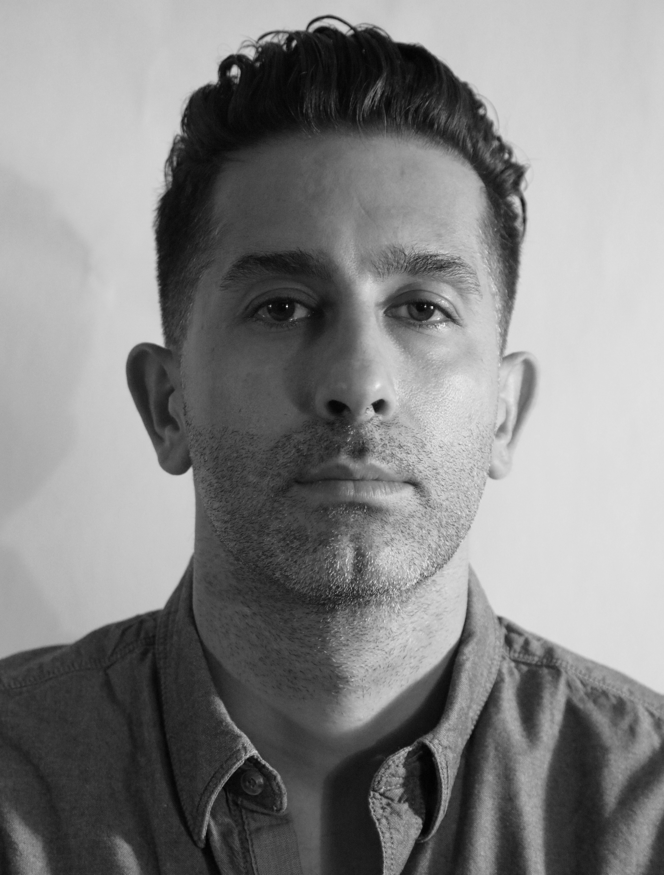

ROUZBEH NEMATI SHARIF
Sculptor
Born in Tehran, Iran 1980

Education:
M.A in Art Research University of Tehran 2006
B.A in Industrial Design Art & Architecture Azad University of Tehran 2003

Lecturer at:
Work as a lecturer of Design in Tehran Institute of Technology 2010

Solo exhibition:
"THE END OF THE IMMORTAL", Soo contemporary Gallery , Tehran

Group Exhibitions:
2022 Group Show,"14th Fajr Visual Arts Festival, Tehran
2021 Group Show, "30 sculpture,30 sculptor", artibition Gallery, Tehran
Group show," Remembering-Being", Soo Contemporary Gallery, Tehran 2021
2021 Group show," ROCK , PAPER ,SCISSOR", NEGAH Gallery, Tehran
Group show," Birds", Soo Contemporary Gallery, Tehran 2021
2021 Group Show, "Last Annual of Century, White Line Gallery, Tehran
2021 Group Show,"13th Fajr Visual Arts Festival, Tehran
2020 Group Show, "Surface-Space", Iranshahr Art Gallery, Tehran
2019 Group Show, "The 3rd Sculpture Expo of Iran, Art Design Gallery, Tehran
2018 Group Show, "FIGURATIVE", Iranshahr Art Gallery, Tehran

